SKEENA SUSTAINABILITY ASSESSMENT FORUM
Forestry Working Group – Roads Subcommittee

“SSAF SC Road App” Supporting Guidebook

Date: July 10, 2023
Draft 1.0

Compiled by: Mike Birks, RPF Mike.Birks@gov.bc.ca
MOF Skeena Stikine Natural Resource District

TABLE OF CONTENTS
1. Introduction 4
2. SSAF SC Road App - Attributes, Domain Names/ Definitions 5
Attribute (1) ROAD TYPE 5
Highway 5
MOT-Road 5
Resource Rd - Main 6
Resource Road - Branch 6
Resource Road - InBlock 7
Resource Road - Trail - Other 7
Recreation - Trail 8
Attribute (2) SURFACE TYPE 9
Paved 9
Gravel 9
Compacted/ Mineral Soil 10
Organics 10
Unknown 10

Attribute (3) STATUS CODE 11
Proposed 11
Existing 11
Daactivated 11
Overgrown 12
Rehabilitated 12

Attribute (4) ACCESS 13
2WD 13
4WD 13
ATV 14
Impassible 14
Proposed 14
Unknown 14

Attribute (5) STRUCTURE TYPE 15
Bridge 15
OBC - Open-Bottomed Culvert 15
WBC - Wood-Box Culvert 16
CMP - Corrugated Metal Pipe 16
CPP - Corrugated Plastic Pipe 17
Ford 17
Gate/ Barricade 18
Retaining Wall 18
Pulled 18
Attribute (6) STRUCTURE CONDITION 19
Functioning 19
Partially Functioning 19
Non-Functional 19

Attribute (7) SEDIMENT INPUT/ TRANSPORT POTENTIAL 20
Low 20
Moderate 20
High 21
Very High 21

ISSUES DESCRIPTIONS 22

3. road terms 29
Fill Slope 29
Cut Slope 29
Road Prism 29
Beaver Stop 29
Ditch 30
Ditch Block 30
Sump 31
Flume 31
Inlet 31
Outlet 31
Armouring 32

- INTRODUCTION

This guidebook is intended to support the field use of the SSAF SC Road App for collecting and improving road data within the SSAF ESI area.
The guidebook is organized by the different road Attributes that are collected with the app (Road Type, Surface Type, Status Code, Access, Structure Type, Structure Condition, and Sediment Input/Transport Potential). For each Attribute there are a pre-established set of Domain Names which can be selected within the app. The guidebook provides definitions and example photos for the Domain Names.
Definitions and example photos are also provided some of the potential road issues (entered in the app under Comments) which individuals using the app may encounter while in the field, as well as for some common road terminology. Please note that the road issues listed in this document are not exhaustive of what could be encountered on the road.
Some Attributes and road issues may be difficult to identify without sufficient training. If an app user is unsure or uncomfortable choosing a Domain Name for a given Attribute please select Unknown as the default. If an app user sees a road issue that is not listed in this guidebook please make as descriptive a comment as you are able and take lots of pictures.
As this is Draft 1.0 of this guidebook, we are looking for user feedback on ways in which it could be improved.
Thank you.

- SSAF SC ROAD APP - ATTRIBUTES, DOMAIN NAMES/ DEFINITIONS
Attribute (1):  Domain Name: |  | Road Type  Definition:
Highway |  | Hwy 16, Hwy 37, Hwy 113, Hwy 62, Hwy 118, Hwy 35
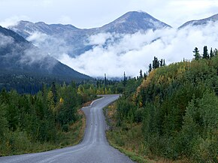
Figure 1 Highway 37

MoT – Road |  | A road maintained by the Ministry of Transportation. May be difficult to distinguish from other roads in the field as they may be gravel or paved and in varying states of maintenance.  To address this difficulty -a simplified spatial file of all MoT Roads as of 2023-07-14  (derived from WHSE_IMAGERY_AND_BASE_MAPS.MOT_ROAD_FEATURES_INVNTRY_SP) is made available to SSAF partners at the following FTP site location, for inclusion on field maps:  https://www.for.gov.bc.ca/ftp/DSS/external/!publish/ESI/
Resource Rd – Main |  | Generally 2 way haul. Public may very well be on these roads. Well maintained.
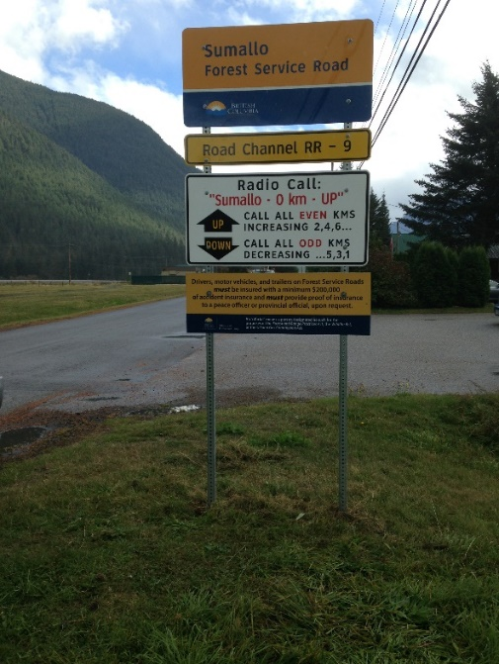
Figure 2 Typical signage at the front of a main Resource Road
Resource Rd – Branch |  | Generally 1 way haul. Roads that comes off of the main roads and lead to cutblocks. Road surface & access type variable - depends on time of year for construction, terrain, soil type etc.
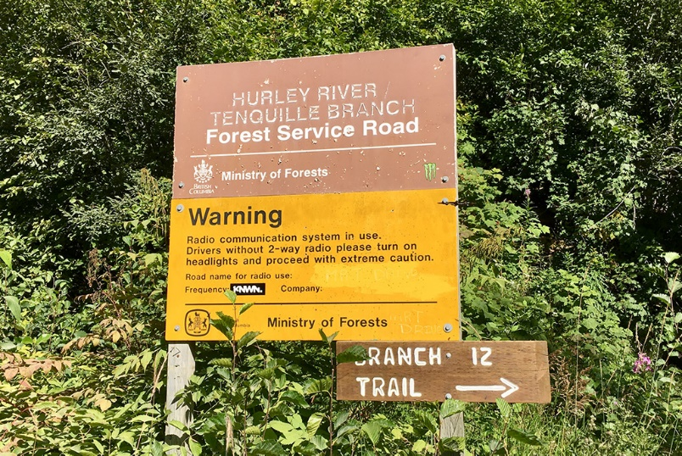
Figure 3 Typical Branch FSR signage

Resource Rd – In Block |  | Roads that are constructed within Cutting Permit tenure. May or may not contribute to permanent access.
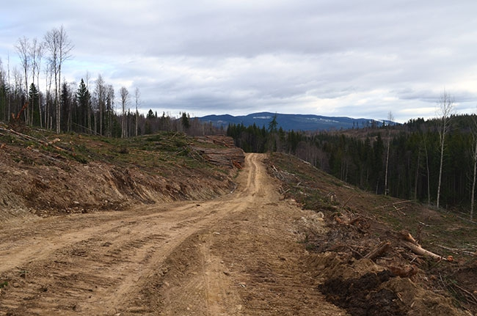
Figure 4 In block dirt road

Resource Rd – Trail/Other (eg. Bladed skidtrail) | Bladed trails, the old bark beetle access roads etc.
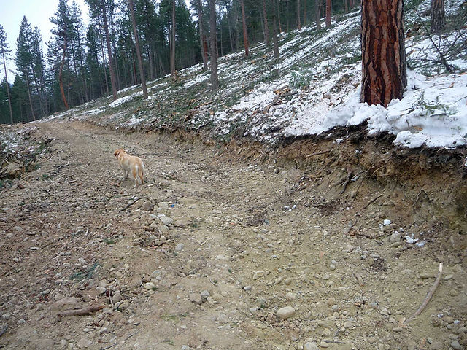
Figure 5 Bladed Skid Trail

Recreation - Trail |  | Recreational snowmobile/ ATV trails, established hiking trails
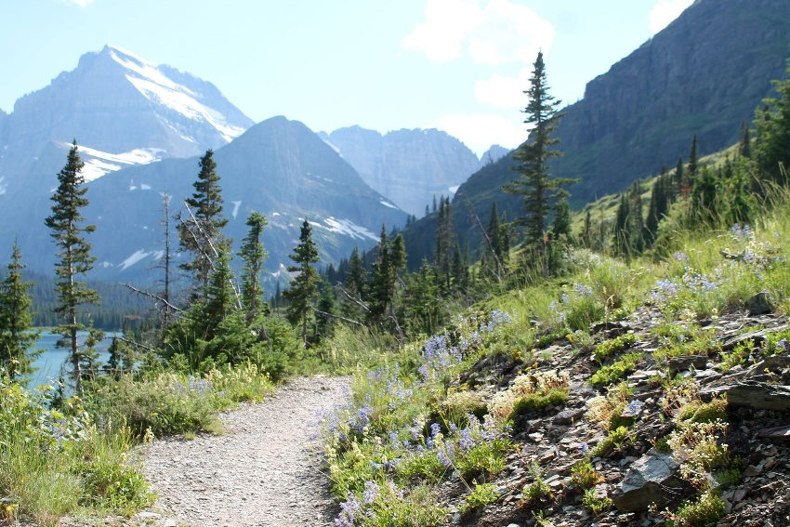
Figure 6 ATV/hiking trail

Attribute (2):  Domain Name: | Surface Type  Definition:
Paved | Includes pavement, seal coat, concrete, asphalt.
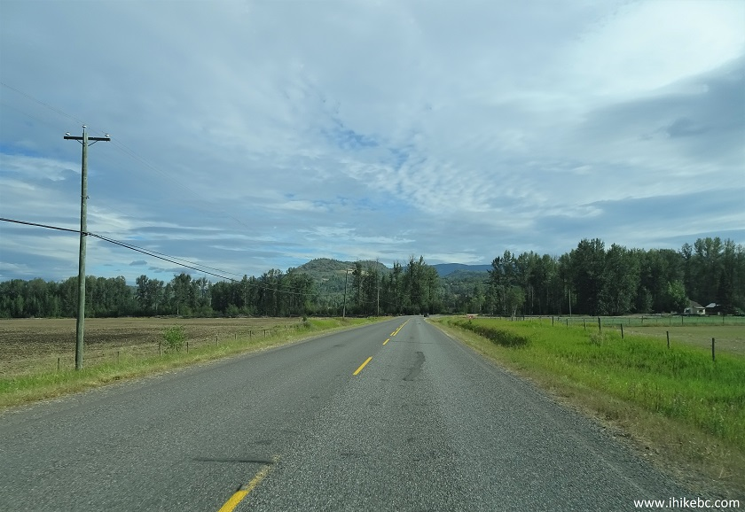
Figure 7 Paved rural road

Gravel
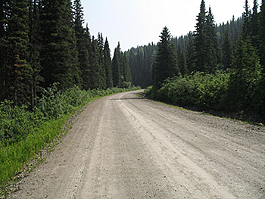
Figure 8 Maintained Gravel Road

Attribute (2):  Domain Name: | Surface Type  Definition:
Compacted/Mineral Soil | Examples would be block road with little to no gravel, bladed areas down to mineral soil
Figure 9 In block dirt road
Organics | Examples would be winter roads / areas where rig mats were removed. Roads that have grass growing on it. High likelihood these areas will be inaccessible after a season
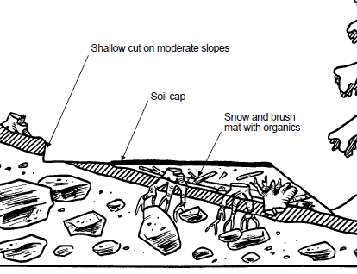
Figure 10 A winter snow-fill road built over organics with minimal ground alteration. May be difficult to distinguish in the summer since it is mostly stumps and slash
Unknown | Indicates roads that may need a field visit to determine Surface Type

Attribute (3):  Domain Name: | Status Code  Definition:
Proposed | Proposed mainline or branch road, not in-block roads
Existing | Road was constructed & is not overgrown or rehabilitated.
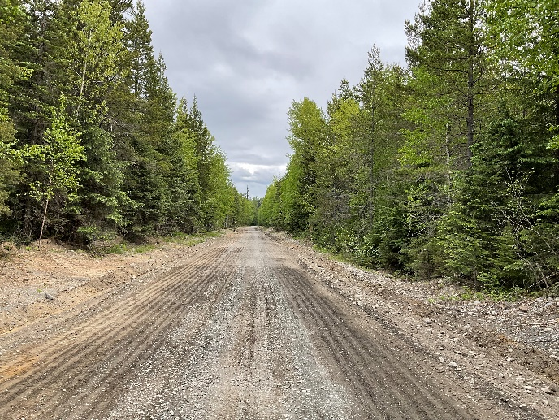
Figure 11 Built and existing road
Deactivated | Per FPPR Deactivation definition. Road surface is still intact but structures have been removed, water bars in place & access limited
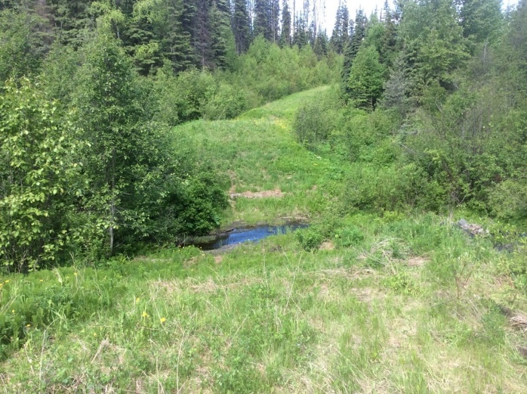
Figure 12 Grassy deactivated road. Cross ditch in foreground

Attribute (3):  Domain Name: | Status Code  Definition:
Overgrown | Road has continuous high-density (i.e. >30% cover distributed across full road width) woody brush / trees growing out of it.
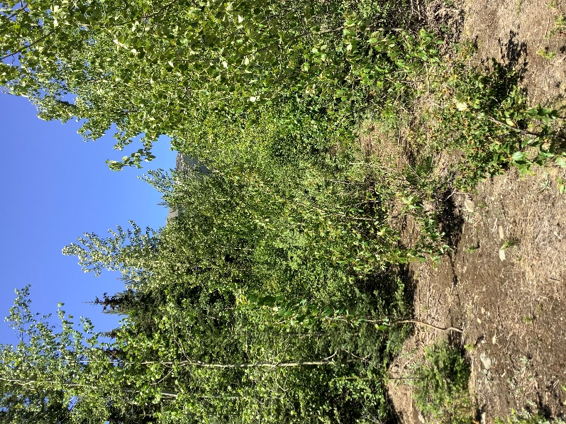
Figure 13 Road covered with brush and impassible with any vehicle
Rehabilitated | Rehabilitated: road has had recontouring / decompaction work completed. - ie. Cannot drive a vehicle down.
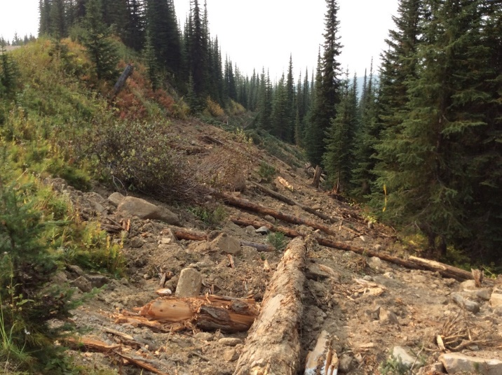
Figure 14 Rehabilitated road with road surface decompacted and recontoured and slash scattered across road

Attribute (4):  Domain Name: | Access  Definition:
2WD | A hard surfaced (“paved”) or well-maintained gravel road capable of travel by a 2-wheel drive vehicle
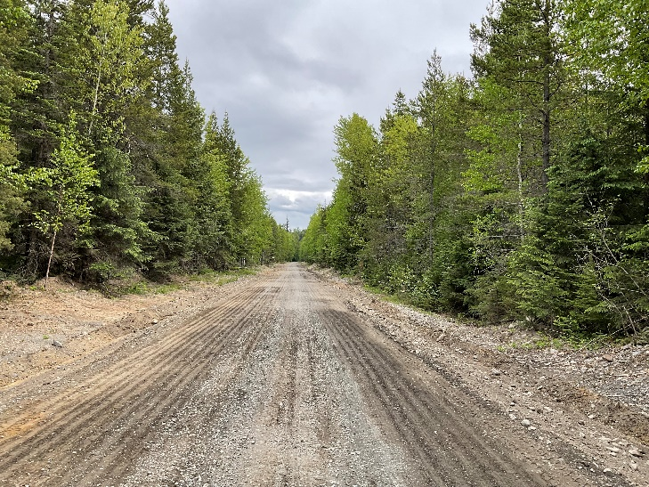
Figure 15 Maintained resource road accessible by 2WD
4WD | A gravel or dirt road capable of travel by a 4-wheel drive vehicle. May not be regularly maintained, can have shallow deactivation features present, can have low to moderate density brush present
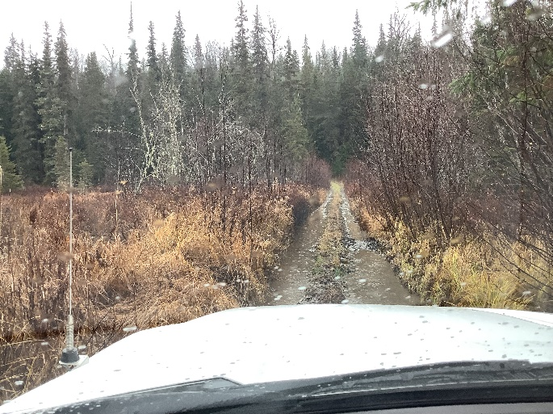
Figure 16 Non-maintained road only accessible by 4WD

Attribute (4):  Domain Name: | Access  Definition:
ATV | A gravel or dirt road capable of ATV travel only. Can have moderately deep deactivation features present (e.g. pulled major culverts or tank traps), may have low density brush present throughout the road prism or be brushed in along sides restricting access to the road centerline
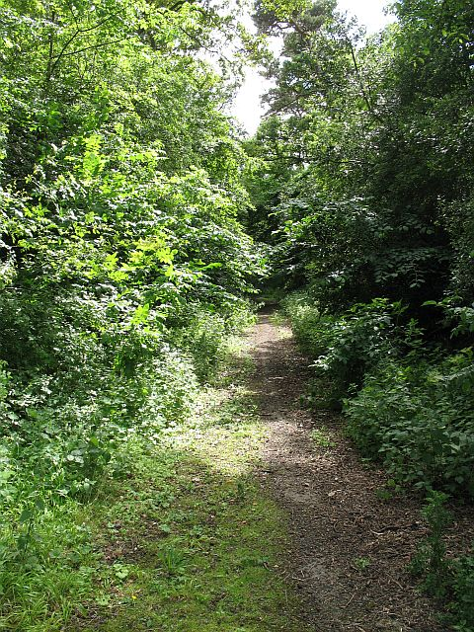
Figure 17 Overgrown road accessible by ATV
Impassible | A gravel or dirt road that is impassible to a motorized vehicle regardless of the season of use. Reasons may include presence of very deep deactivation features (e.g. pulled bridges), piling of stumps within the road prism and ROW for >100 meters, and/or road is overgrown or rehabilitated. An access-controlled road (e.g. gated, temporary lock blocks) does not qualify as “impassible”.
Proposed | Road is planned but not yet constructed
Unknown | Accessibility is unknown; may need a field visit to determine.

Attribute (5):  Domain Name: | Structure Type  Definition:
Bridge | A temporary or permanent structure carrying a road above a stream or other opening
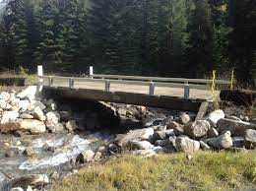
Figure 18 Bridge on a Resource Rd
Open-Bottomed Culvert/Arch | A drain pipe that allows for the natural stream bed to remain intact beneath the road allowing for fish-friendly passage
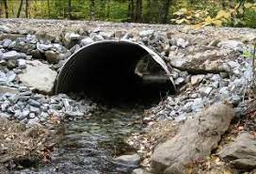
Figure 19 Open bottom culvert with natural stream channel

Attribute (5):  Domain Name: | Structure Type  Definition:
Wood Box Culvert (Log Culvert) | A log structure less than 6m long carrying a road above a stream or other opening (A log structure greater than 6m is a log bridge)
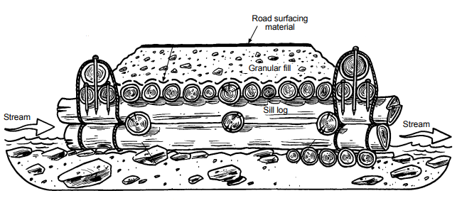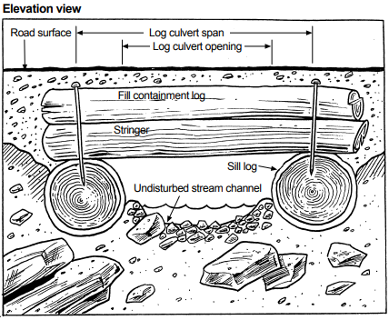
Figure 20 Illustrations showing the construction of a wood box culvert

CMP | Corrugated Metal Pipe. A metal drain pipe covered with soil and lying beneath the road (embedded in the road) surface used to carry either stream or ditch water from one side of the road to the other
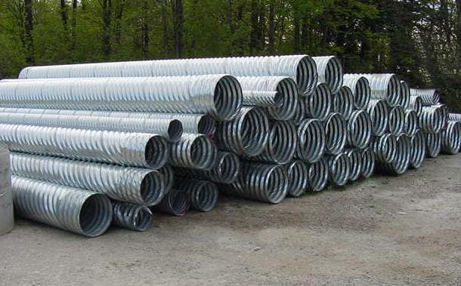
Figure 21 Corrugated Metal Pipes

Attribute (5):  Domain Name: | Structure Type  Definition:
CPP | Corrugated Plastic Pipe. A plastic drain pipe covered with soil and lying beneath the road (embedded in the road) surface used to carry either stream or ditch water from one side of the road to the other
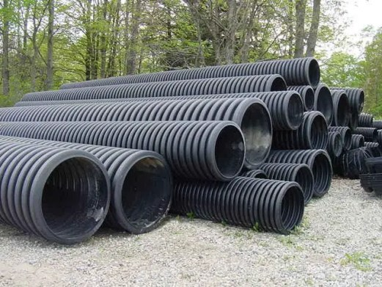
Figure 22 Corrugated Plastic Pipes
Ford | A dip in a road constructed to facilitate crossing a stream
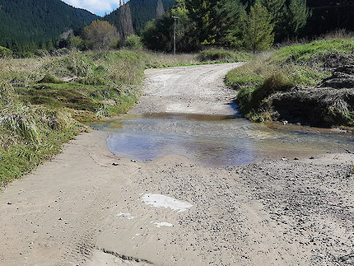
Figure 23 Ford crossing through a stream

Attribute (5):  Domain Name: | Structure Type  Definition:
Gate/Barricade | Eg. A locked structure blocking access on the road; lock blocks blocking the road
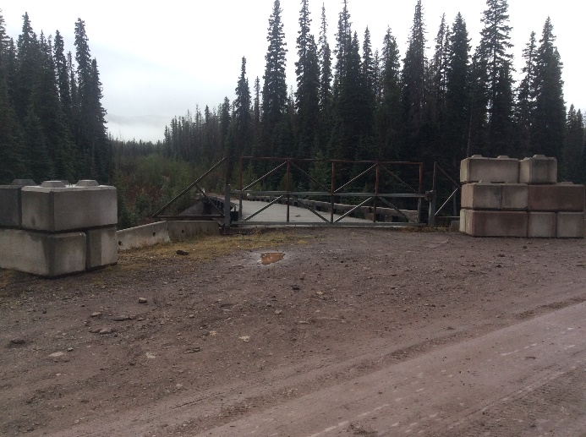
Figure 24 Gate blocking access to road
Retaining Wall | A wall intended to hold soil in place and/or to keep soil from spilling onto the road
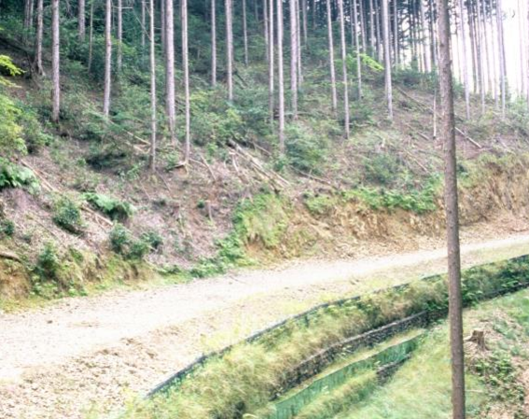
Figure 25 Retaining wall built on low side of road
Pulled | A point in the road where a structure has been removed
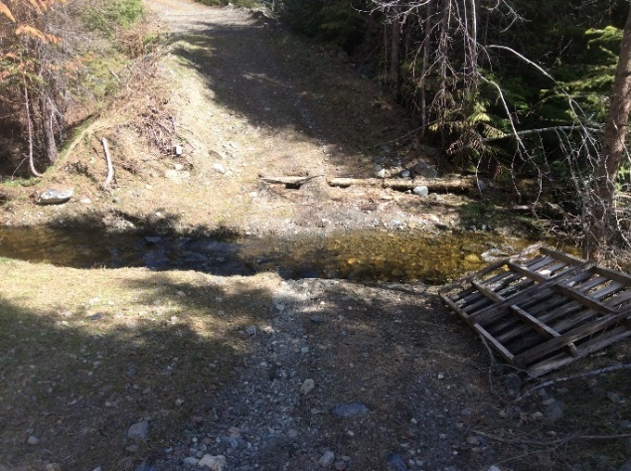
Figure 26 Road crossing where a crossing structure has been removed

Attribute (6):  Domain Name: | Structure Condition  Definition:
Functioning | Structure is working as intended with no adverse impacts to water or road and no need for repairs or maintenance.  Structure is allowing for the unobstructed movement of water at full flow and is not causing sedimentation of a waterbody or negatively affecting the integrity of the road (eg. no erosion, no unintended pooling of water around structure, no damage to structure, no damage to road)  Eg. A properly sized culvert that is passing all the water it is required to; no erosion around the inlet or outlet; no unintended pooling of water at inlet or plunge at outlet
Partially Functioning | Structure is not working at full capacity and has potential to deteriorate further without maintenance.  Movement of water is partly obstructed and issues (damage to structure, erosion, etc.) are beginning to be observed.  Eg. A partially plugged culvert that is still able to pass enough water at some times of the year but maybe not during high flow periods. May be signs of water pooling at inlet and causing erosion around inlet. Is at risk of getting more plugged and causing more damage
Non-Functional | Structure not working as intended and is resulting in damage to water or road and requires significant repairs or replacement.  Movement of water is obstructed to the extent that significant sedimentation and/or damage to the road is occurring, or is at risk of occurring.  Eg. A culvert that is either entirely plugged or plugged enough that it can no longer pass enough water to prevent damage and/or sedimentation from occurring

Attribute (7):  Domain Name: | Sediment Input/ Transport Potential  Definition:
Sedimentation: the movement of soil into a waterbody
Sedimentation potential does not mean what is happening at the moment when the site is visited but what could happen under the right conditions. For example, if a stream is dry or if it hasn’t rained recently there may not be any active sedimentation but imagine what would occur at the site when water is present. Is there an issue which would emerge under rainy conditions that doesn’t occur under dry conditions?
*Please Note: If you have not received the FREP Water Quality Effectiveness Evaluation training, or an equivalent training on sediment potential, please select Unknown as the default answer for this attribute.
Low | Unlikely that sedimentation will occur as a result of what is observed. No maintenance action is required.
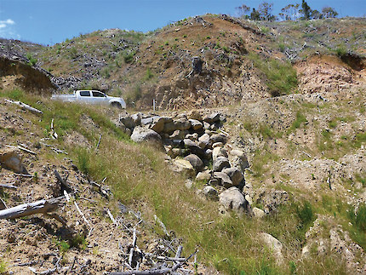
Figure 27 Armouring around outlet of culvert creating low sedimentation potential by giving the water a clean surface to exit the culvert onto
Moderate | Some concerns noted and likely that a small amount of sedimentation will occur. Maintenance is not immediately required.
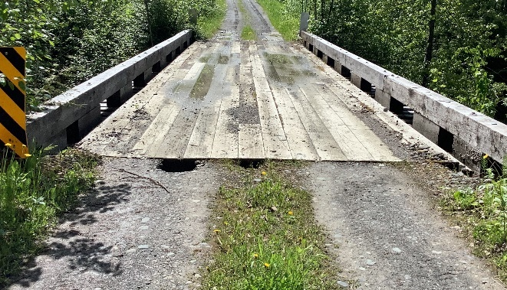
Figure 28 Soil being lost from the road at the edge of the bridge moving down towards stream. It may or may not end up in the stream.

Attribute (7):  Domain Name: | Sediment Input/ Transport Potential  Definition:
High | Likely that a large amount of sedimentation will occur and requires maintenance.
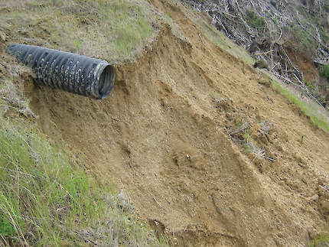
Figure 29 The drop at the outlet of the culvert will cause water to pick up and transport sediment downhill, into a stream if there is one there
Very High | Extremely likely that a large amount of sedimentation will occur. Major water quality problems exist at a landscape level and immediate action is required.
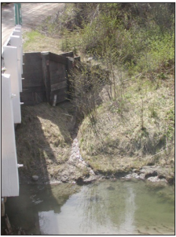
Figure 30 A long continuous ditch line drains directly into a stream

Issue Descriptions
Examples of issues frequently encountered during road inspections.
- Please Note that this is not a comprehensive list of potential road issues
Poor Ditching | Ditch no longer transporting water to desired location (eg. Into a culvert)
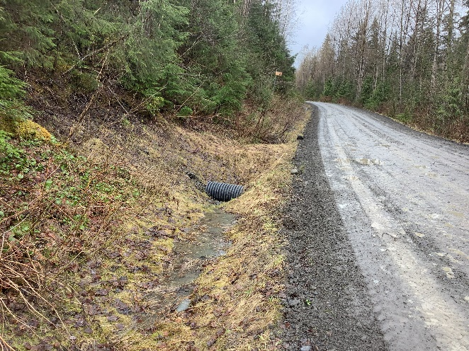
Figure 31 Stagnant water not ditched to the inlet of the culvert. Ditch block behind culvert.
Plugged Beaver Stop | Beaver stop becoming clogged with debris and causing (or in danger of causing) a reduction in culvert functioning
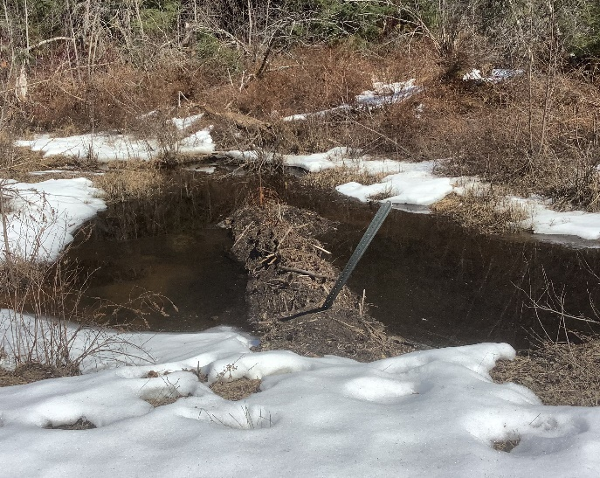
Figure 32 Beaver stop on outlet of culvert mostly plugged by beaver

Flume Detached from Culvert | Flume has become separated from culvert outlet and is no longer transporting water to the desired location
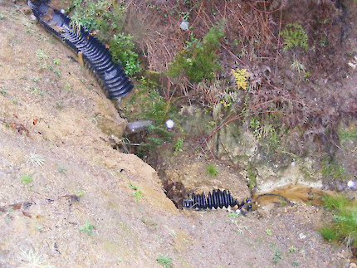
Figure 33 Part of the flume has become detached and erosion is occurring
Crushed/Collapsed Culvert | A culvert which has been crushed/collapsed at any point along its length and no longer capable of passing the intended amount of water
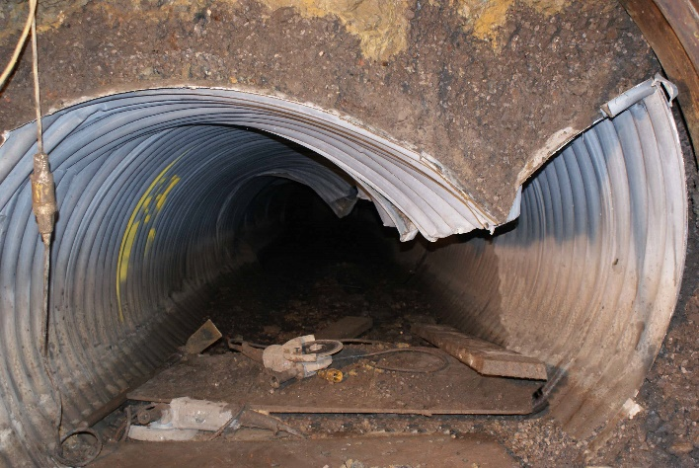
Figure 34 Partially collapsed culvert

Perched Culvert | Where the culvert outlet hangs above the level of the stream bottom creating a waterfall-like plunge of water. Creates a barrier for upstream movement of fish on fish streams. Excessive plunge on non-fish streams can also
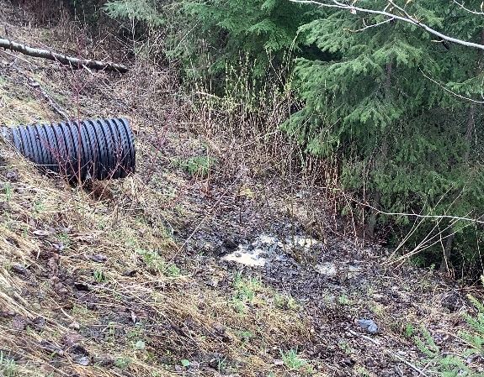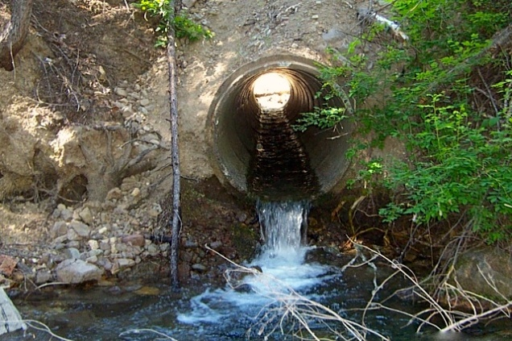
Figure 35 Perched culvert with water dropping onto fill slope Figure 36 Perched culvert with plunge pool on a stream
Plugged Culvert | A culvert which has become filled with sediment or debris and is no longer capable of passing enough water
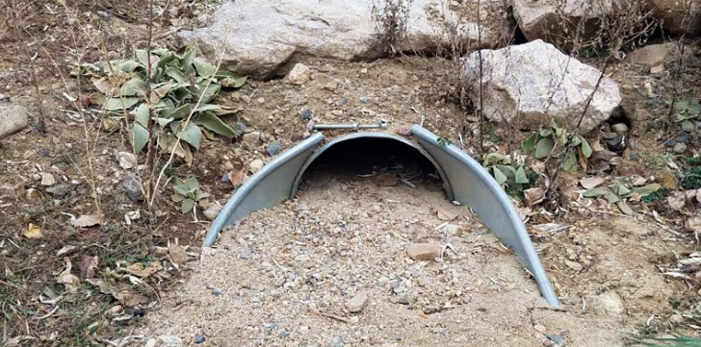
Figure 37 Culvert plugged with sediment

Piping Culvert | Where water is passing through the road prism around/below the culvert rather, or in addition to, through the culvert
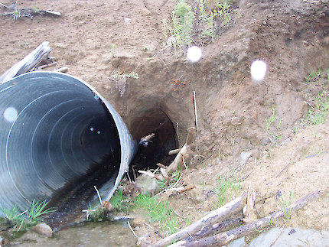
Figure 38 Water eroding and passing around culvert rather than through it
Collapsed/Rotten Wood Box Culvert | Logs from the Wood Box Culvert becoming very soft or broken
Slide | A downslope movement of soil or rock. Generally either beginning at the road and travelling down or beginning above the road resulting in material landing on and covering road. Often a rapid occurrence
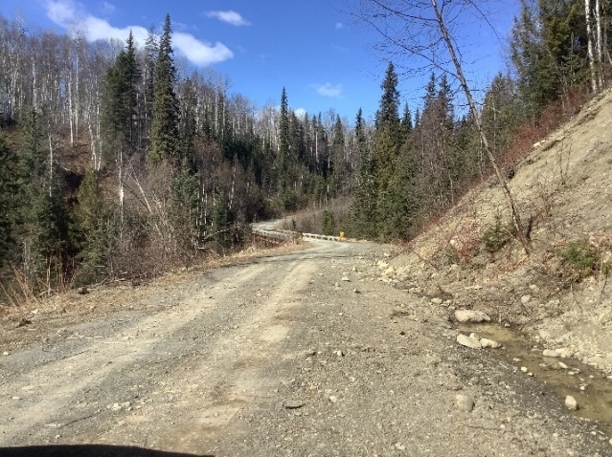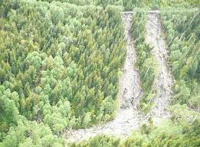
Figure 39 Slide beginning to accumulate material on road Figure 40 Slide beginning at the road

Slump | A mass of earth moves down a slope a short distance (rather than sliding all the way down). Often caused by saturation, undercutting, or overloading of the fill slope
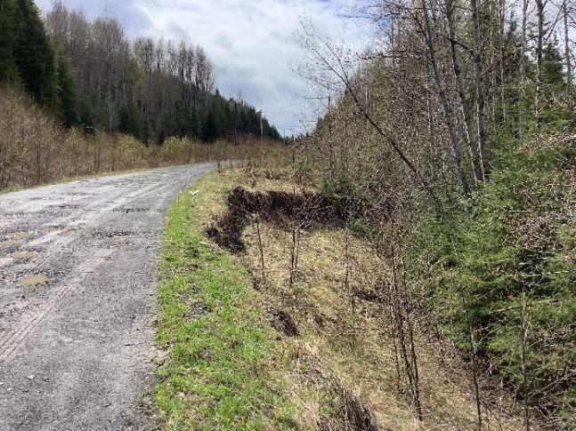
Figure 41 Fill slope slump
Surface Erosion | Occurs where water remains on road surface rather than being shed to the side, causing water to drain improperly. Results in channels being washed out on the road surface and sediment transport down roads rather than in ditches
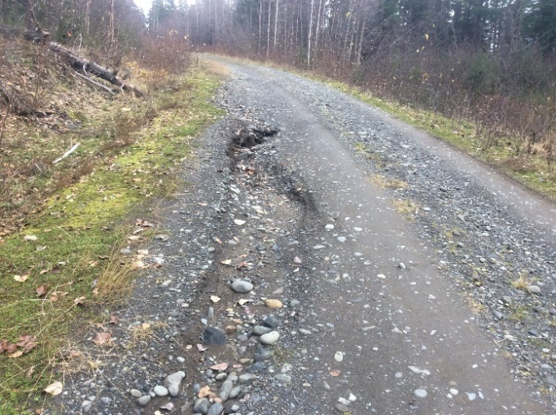
Figure 42 Surface erosion on road
Tension Crack | A crack running down the length of a road. May indicate unstable soil downslope of road.
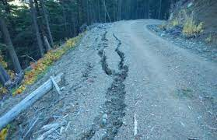
Figure 43 Tension cracks running along the edge of a road

Tilting Trees Below Road | May indicate slumping downslope of road. As soil moves downward trees become tilted as their roots are shifted
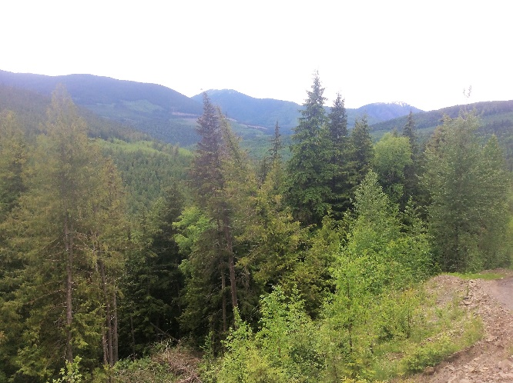
Figure 44 Tilting tree below road
Sediment Accumulation on Bridge Deck | Sediment from road surface flowing onto bridge deck with a high likelihood of entering stream. May occur where bridge is located at the bottom of a hill
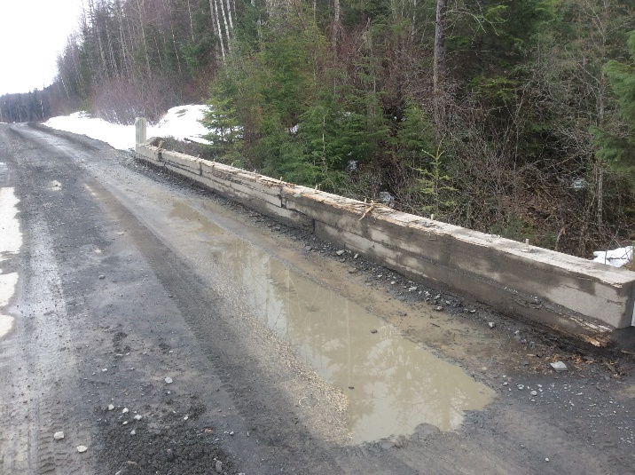
Figure 45 Sediment accumulating on bridge

Loss of Fill on Bridge | Road material from around the end of a bridge washing away towards stream. Bridge should hold back road material to prevent sediment from reaching stream
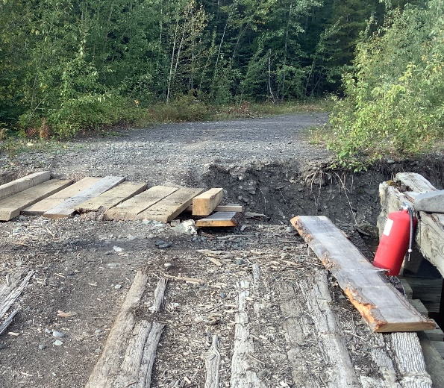
Figure 46 Loss of fill before bridge Figure 47 Significant loss of fill at the approach to the bridge
Non-Functioning Ditch Block | Ditch block no longer diverting water though culvert. Water may be continuing in ditch causing damage further down the ditch or redirected onto road surface
Non-Functioning Sump | Sump filled with sediment and no longer able to collect more sediment without being emptied
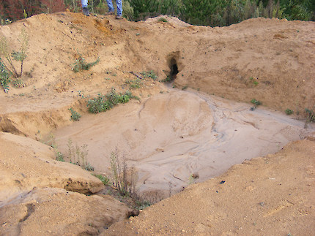
Figure 48 Filled sump, no space to catch more sediment unless it is emptied
Fan Influences

- ROAD TERMS
Fill Slope | the face of an embankment required to raise the desired road profile above the natural ground line. The downhill side of the road
Cut Slope | the face of an excavated bank required to lower the natural ground line to the desired road profile. The uphill side of the road
Road Prism | The width of road construction from the bottom of the fill slope to the top of the cut slope.
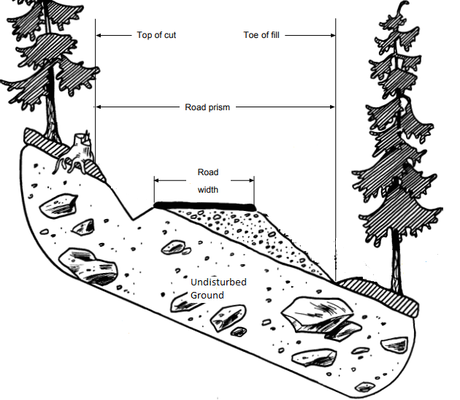
Figure 49 Width of road prism from top of cut to bottom of fill
Beaver Stop | A grate added to the inlet of a culvert intended to make it more difficult for a beaver to plug the culvert
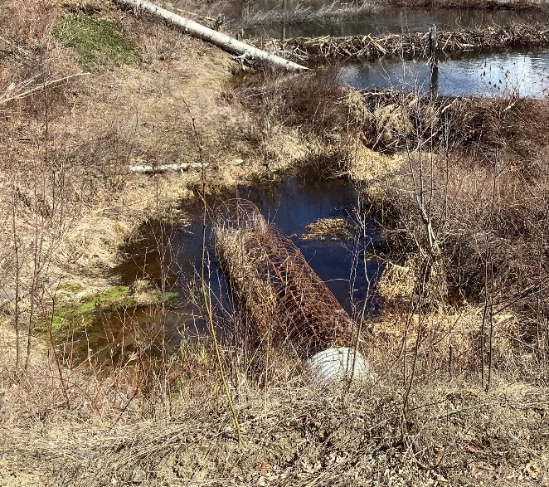
Figure 50 Beaver stop on the inlet of a culvert

Ditch | A narrow channel running immediately parallel to the road intended to collect and transport water away from the road and/or sensitive ground
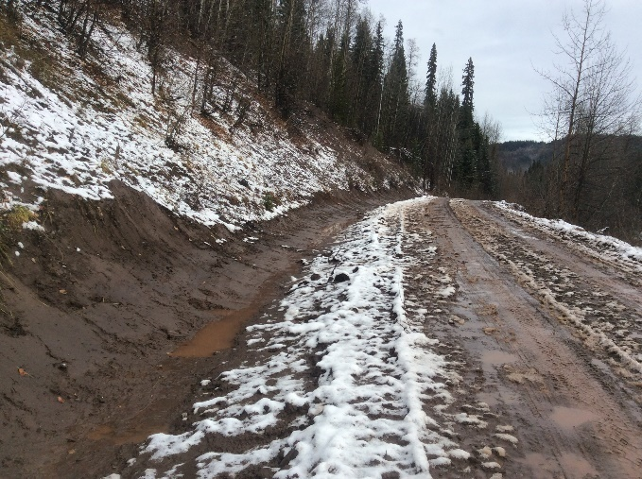
Figure 51 Recent ditching along road
Ditch Block | A dam in the ditch located on the downslope side of the inlet to a culvert, forcing water to divert from the ditch and through the culvert. Should be at least as high as the culvert but slightly lower than the road surface so that water remains in the ditch in case the culverts become damaged or plugged
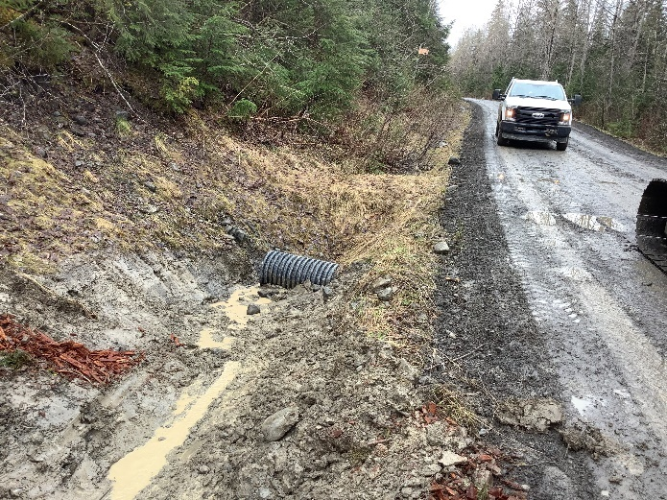
Figure 52 Water properly ditched into the outlet of a culvert. Ditch block behind culvert.

Sump | An excavated hole intended to allow water to slow down and allow sediment to settle out before water reached a waterbody. Require regular maintenance to keep clear.
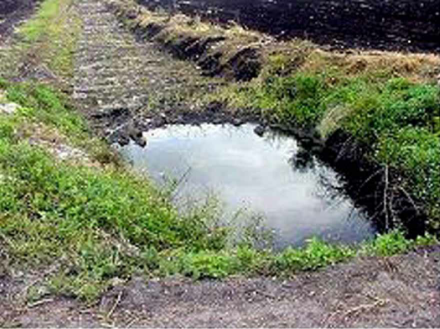
Figure 53 Water pooling in a sump at the end of a ditch
Flume | A half-culvert or pipe added to the outlet of a culvert intended to transport the water from the culvert further away from the culvert outlet before being deposited on the ground. Generally intended to transport water away from a fill slope to avoid the slope becoming saturated and potentially unstable
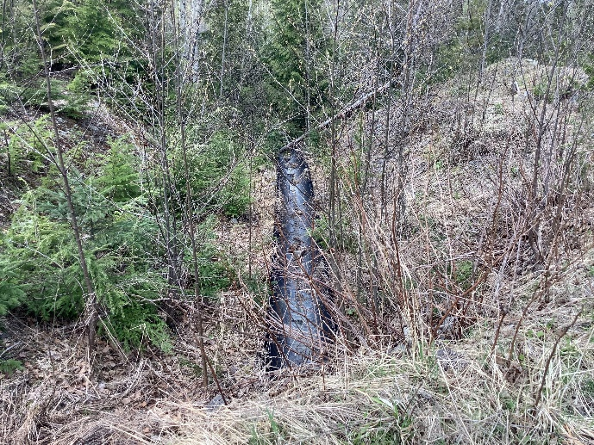
Figure 54 Flume attached to culvert outlet (culvert is hidden at the bottom of the photo)
Inlet | End of the culvert where water enters
Outlet | End of the culvert where water exits

Armouring | Use of some material (generally rocks) to provide erosion control around a structure or along a road or ditch
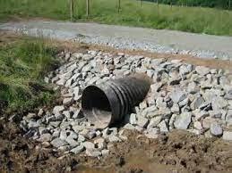
Figure 55 Culvert armoured with rock to prevent erosion

Forest Service Road sign standards - Province of British Columbia (gov.bc.ca)
FSR sign - Outdoor Therapy
Managing resource roads - Rock to RoadRock to Road
KNP Logging Nearing Completion (kimberleynaturepark.ca)
The Top 5 Best Hikes In Montana (onlyinyourstate.com)
Malkow Lookout Trail Hike (near Smithers BC) - ihikebc.com
Gravel Roads - Jackson County, Oregon (jacksoncountyor.org)
Managing resource roads - Rock to RoadRock to Road
FOR Engineering Manual - Province of British Columbia (gov.bc.ca)
Deactivating forest roads to protect the surrounding environment - FPInnovations
Project Profile: Adams Groundhog Road Rehabilitation and Reforestation Project - Habitat Conservation Trust Foundation (hctf.ca)
SIR38 Bridge Planning Design and Construction (bcfpb.ca)
Slide 1 (wellsreserve.org)
FRE Layout (gov.bc.ca)
Acton Precast Concrete Limited
culvert pipes: meaning, types, uses - Studentlesson
NZ Forest Road Engineering Manual: Operators Guide • NZ Forest Road Engineering Manual: Operators Guide (nzfoa.org.nz)
Forest road retaining technologies on difficult slopes in Japan | Semantic Scholar
NZ Forest Road Engineering Manual: Operators Guide • NZ Forest Road Engineering Manual: Operators Guide (nzfoa.org.nz)
NZ Forest Road Engineering Manual: Operators Guide • NZ Forest Road Engineering Manual: Operators Guide (nzfoa.org.nz)
FREP_Extension_Note_12.pdf (gov.bc.ca)
NZ Forest Road Engineering Manual: Operators Guide • NZ Forest Road Engineering Manual: Operators Guide (nzfoa.org.nz)
Pipe Jacking solution solves culvert collapse – UKDN Waterflow
Crossing & Culvert Maintenance - streamhandbook.org
NZ Forest Road Engineering Manual: Operators Guide • NZ Forest Road Engineering Manual: Operators Guide (nzfoa.org.nz)
Lmh66_ch09.pdf (gov.bc.ca)
SIR47 - Resource Road Construction in Steep Terrain (bcfpb.ca)
NZ Forest Road Engineering Manual: Operators Guide • NZ Forest Road Engineering Manual: Operators Guide (nzfoa.org.nz)
FOR Engineering Manual - Province of British Columbia (gov.bc.ca)
NZ Forest Road Engineering Manual: Operators Guide • NZ Forest Road Engineering Manual: Operators Guide (nzfoa.org.nz)
NZ Forest Road Engineering Manual: Operators Guide • NZ Forest Road Engineering Manual: Operators Guide (nzfoa.org.nz) All other photos provided by Ministry of Forests staff

